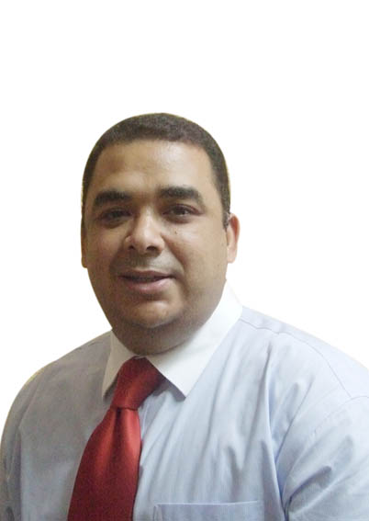

hassanels@hotmail.com Cell: + 965 90903147

helmasri@kuwait-fund.org Dir:96522999000 Ext.9143
Languages spoken and written: English, Arabic, Intermediate knowledge of French
Excellent working knowledge of Microsoft Office applications, dual citizenship Canadian and Egyptian.

Legal Employment History

Kuwait Fund for Arab Economic Development, LEGAL ADVISOR.
January 2013 to present Kuwait city
- Drafting loans and grantors agreement between Kuwait Fund and developing countries.
- Review of feasibility studies for development project, as well participation in the appraisal of many project in such as constructions, agriculture, water and sanitation, energy and transportation.
- Providing legal advice on various aspects of the fund development operation internationally.
- Advising Kuwait Fund on its project financing activities in developing countries in Asia, Africa, Central Europe, Central America, Latin America & the Caribbean, and the Middle East.
- Drafting joint venture contract, options agreement and legal risk analysis for international investment.
- Judicial litigation in the areas of civil, commercial and Administrative litigation in the areas of administrative law and regulations of several industries
- Arbitration involving infrastructure and corporate disputes
Legal terminologist, Biztree inc , Montreal, Canada.
July 2010 - July 2011
➢ Translate the legal documents from English to Arabic
- Auditing and review the Arabic legal documents before publishing
- Translate software business documents.

State Lawsuit Authority, EGYPT

June 1996 - 2013: Member of State Lawsuit Authority
Senior State counsel

- Joined the Egyptian State Lawsuits Authority (ESLA) by virtue of the Presidential Decree No. 222/1996. Served as a Senior State Counsel in numerous civil, administrative, criminal, commercial and arbitration courts.
- Assignments were mainly related to highly significant pending investor-state disputes in accordance to the arbitration rules of the International Centre for Settlement of Investment Disputes (ICSID), the International Court of Arbitration of the International Chamber of Commerce (ICC) or the Cairo Regional Centre for International Commercial Arbitration (CRCICA).
- Handled a lot of cases involving business law issues; such as merger and acquisitions, international transaction, corporate law, and abuse of power ...etc before the Court of Administrative Judiciary in Cairo as a State Attorney.
- Provided legal opinion for the Egyptian Ministers in Commercial matters, civil cases and administrative cases.
- Generally, the work assigned included drafting of memoranda, preparation of binders, direct and cross examination of witnesses, developing legal researches, gathering of legal authorities, drafting of settlement agreements and appearance before domestic and international arbitral tribunals as counsel for the Arab Republic of Egypt, in addition to serving as a trial State Counsel before the courts in Egypt.

Education

2008- 2010 Faculty of Law, University of Montreal, Canada, Master of Laws
LL.M, Concentration: Business Law in Global Context, scholarships
from Canadian government " Canada Millennium Scholarship"

1993- 1988 Bachelor of law
Cairo University, Faculty of Law, LL.B, Egypt
Legal Research
➢ The Federal Act on the Restitution of Assets of Politically Exposed
Persons obtained by Unlawful Means (RIAA) Published at shorouk
News paper. Electronic versions are available at
http://shorouknews.com/Columns/Column.aspx?id=429072 http://papers.ssrn.com/sol3/papers.cfm?abstract_id=1872826
- “Issues of Sovereign and State Entities in International Arbitration: A Look into Investor-State Arbitration”- Under Supervision of distinguished Professor Guy Lefebvre, Associate Dean for Development, Graduate Studies and Research, Faculty of Law, Université de Montréal, Québec, Canada.
- “The Baramita Gold Project (BGP), Cooperative Republic of Guyana”: I drafted the international contracts such as joint Venture, Mineral Agreement, Optional agreement, Impact and benefit Agreement (IBA) and Arbitration Agreement Under supervision of Professor Louis Omer Peloquin, Graduate Studies and Research, Faculty of Law, Université de Montréal, Québec, Canada
- “E-mail as evidence”, Social Science Research Network. Electronic version available at http://papers.ssrn.com/sol3/papers.cfm?Abstract_id=1533107
- “Financial scandals and new Structure for regulating the capital market in Egypt”, (published in law Journal, State lawsuit Authority Egypt,vol2 June 2008)
Training course

- Courses of preparation for arbitrator , Cairo, Egypt
- Regional trade Agreements under WTO Seminar , Egypt
- Specialized training program in legal English , Contract Drafting and Human rights National Center for juridical studies (NCJS) Egypt.
- Globalization judicial system and Human rights (UNDP)
PROFESSIONAL AFFILLIATIONS
  - CBA, Canadian Bar Association
  - ABA, American Bar Association
  - Egypt’s Bar Association
  - YCPA, Young Chinese professional Association
  - State lawsuit Authority club

References furnished upon request

