Dr. Samir Hammami
Assistant Professor
Chairperson of the Center for Entrepreneurship at Dhofar University
Chairperson of the Community Service and Continuing Education Center
College of Commerce and Business Administration
Management Information Systems Department

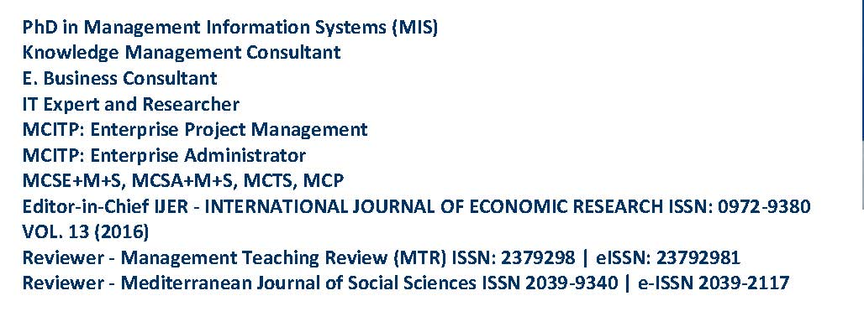
Personal Information
Mobile Phone | 00968 - 98089093
Address | P.O.Box 2509, PC 211, Salalah, Oman
E-Mail (Private) | samir@du.edu.om  samir.hammami@gmail.com
Birth date | 22 Jun. 1974
Gender | Male
Marital Status | Married
Dependents | 3
Nationality | Syrian
Resident of | Salalah - Oman
Driving License | Yes
Education
Academic Certifications | Graduation Year
Ph.D. degree in MIS (Management Information Systems)  Damascus University  The Joint Academic Program between Damascus University and Arab Academy for Banking and Financial Sciences for Postgraduates Studies | 2010
Master Degree in CIS (Computer Information Systems)  Damascus University  The Joint Academic Program between Damascus University and Arab Academy for Banking and Financial Sciences for Postgraduates Studies | 2005
Bachelor’s in Electronic Engineering  Damascus University | 1997
Teaching and Learning
Dhofar University - Oman
Assistant Professor (Master and Bachelor Degree)  Chairperson of the Center for Entrepreneurship at Dhofar University  College of Commerce and Business Administration  Department of Management information Systems | 2014 to Present
www.du.edu.om
Damascus University - Arab Academy for Banking and Financial Sciences for Postgraduates Studies (AABFS) - Syria
Assistant Professor for postgraduate studies | September 2010 to December 2013

Faculty of Information Technology – Department of Management information Systems
International University of Sciences and Technology (IUST) - Syria
Part time teaching (Bachelor Degree) | September 2010 to January 2014
Faculty of Business Administration – Department of Management information Systems
www.iust.edu.sy
Arab International University (AIU) - Syria
Part time teaching (Bachelor Degree) | September 2010 to January 2014
Faculty of Business Administration – Department of Management information Systems
www.aiu.edu.sy
Higher Institute of Business Administration - Syria
Part time teaching (Bachelor Degree) | February 2012 to January 2014
www.hiba.edu.sy
Professional Certifications
E. Business Consultant | www.icecc.com
from the Institute of Certified E-Commerce Consultants / 2007
Microsoft Certification Status
MCITP: Enterprise Project Management | www.microsoft.com
MCITP: Microsoft Certified IT Professional: Enterprise Administrator
MCTS: Microsoft Certified Technology Specialist
MCSE+M+S: Microsoft Certified Systems Engineer: Messaging + Security
MCSA+M+S: Microsoft Certified Systems Administrator: Messaging + Security
MCP: Microsoft Certified Professional
Memberships | Since
Association for Computing Machinery | Since 2004
www.acm.org
Institute of Certified E-Commerce Consultants | Since 2008
www.icecc.com
Engineering Syndicate | Since 1997
www.engreef.com
Syrian Computer Society | Since 1997
www.scs.org.sy

Research and Scholarly Achievements
Research Papers
- 1. Hammami, S. M., & Alkhaldi, F. M. (2017). Individual, Managerial and Collaborative Capabilities of Organizational Knowledge. International Business Management, 11(1), 156-164. doi:10.3923/ibm.2017.156.164
- 2. Hammami, S., Alraja, M. N., & Jamil, S. A. (2015). The role of IT in Enhancing Productivity at Higher Education Institutions from Staff and Students’ Perspective-Evidence from Oman. Journal of Theoretical and Applied Information Technology, 80(3), 464-472.
- 3. Hammami, S., AlSamman, H. M., & Alraja, M. N. (2015). The Role of CRM System in Consolidating the Strategic Position of the Organization. International Journal of Applied Business and Economic Research, 13(4), 1629-1640.
- 4. Hammami, S., Kasem, S., & Alhousary, T. (2015). BA as an Enabler of Knowledge Creation in Elearning Environment. International Journal of Applied Business and Economic Research, 13(4), 1619-1628.

- 5. Hammami, S., & Alkhaldi, F. M. (2012). Enhancing BI Systems Application through the Integration of IT Governance and Knowledge Capabilities of the Organization. In A. Rahman El Sheikh, & M. Alnoukari (Eds.) Business Intelligence and Agile Methodologies for Knowledge-Based Organizations: Cross-Disciplinary Applications (pp. 161-182). Hershey, PA: Business Science Reference. doi:10.4018/978-1-61350-050-7.ch008
- 6. Alraja, M. N., Hammami, S., Chikhi, B., & Fekir, S. (2016). The Influence of Effort and Performance Expectancy on Employees to adopt e-Government: evidence from Oman. INTERNATIONAL REVIEW OF MANAGEMENT AND MARKETING, 6(4), 930-934.
- 7. Alraja, M. N., Hammami, S., & Alsamman, H. M. (2016). Investment in ICT in Developing Countries: the effect of FDI: Evidences from Sultanate of Oman. INTERNATIONAL JOURNAL OF ECONOMICS AND FINANCIAL ISSUES, 6(4), 1632-1636.
- 8. Alraja, M. N., Hammami, S., & Alhousary, T. (2015). Factors Affecting E-Government Services Adoption: Field Study. Journal of Theoretical and Applied Information Technology, 78(1), 65-69.
- 9. Bilal, Z. O., & Hammami, S., & Jamil, S. A. (2016). The Influence of Entrepreneurship Education and Previous Entrepreneurial Experience on Students’ Desirability to Self-Employment: a Case Study of HEIs in Dhofar Region in Oman. International Journal of Economic Research, 13(4), 1737-1749.
- 10. Bilal, Z. O., & Hammami, S., (2015). Supporting Entrepreneurship Context: The Synergy between the Government and Big Companies: a Descriptive Analysis of a Case Study in Oman. International Journal of Economic Research, 12(4 (Part-II)), 1341-1351.
- 11. Kasem, S., Hammami, S., & Alhousary, T. (2015). Applying SECI Model to Encourage Knowledge Creation in Elearning Environment. 12(4(Part I)), 1601-1611.
- 12. Kasem, S., Hammami, S., & Alraja, M. N. (2015). Elearning Environment as a Facilitator for Knowledge Creation Using SECI Model in the Context of BA. Journal of Theoretical and Applied Information Technology, 80(2), 372-380.
- 13. Ahmar Uddin, M., Mohammad, S., & Hammami, S., (2016). Influence of Demographic Factors on the Entrepreneurial Intentions of University Students in Oman. Investment Management and Financial Innovations, 86-91.
- 14. Tadros, I., Hammami, S., & Al-Zoubi, K. (2008). Systems Development Projects. 3rd International Conference on Information and Communication Technologies: From Theory to Applications. ICTTA 2008 (pp. 1-7). Damascus: IEEE. doi:10.1109/ICTTA.2008.4529915
- 15. Tadros, I., Hammami, S., & Al-Zoubi, K. (2008). Government Resources Planning and user satisfaction for Jordan e-government. 3rd International Conference on Information and Communication Technologies: From Theory to Applications. ICTTA 2008 (pp. 1-7). Damascus: IEEE. doi:10.1109/ICTTA.2008.4529943
Journals Reviewing
- 1. Editor-in-Chief IJER - INTERNATIONAL JOURNAL OF ECONOMIC RESEARCH ISSN: 0972-9380 VOL. 13 (2016)
- 2. Reviewer - Management Teaching Review (MTR) ISSN: 2379298 | e-ISSN: 23792981
- 3. Reviewer - Mediterranean Journal of Social Sciences ISSN 2039-9340 | e-ISSN 2039-2117

Community service
- 1. Head of Jury of the first competition “An Entrepreneur and an Idea 2016” for Dhofar University students, Oman, Dec. 2016.
- 2. Chairperson of the workshop “Establishing SMEs, Methodology, Business Plan and Tools” at Dhofar University in collaboration with PROMOTECH CEI (www.promotech.fr) which is a member of the European Business Network (www.ebn.eu) 22 – 23 November 2015.

- 3. Chairperson of the workshop “Feasibility Studies for Small Projects” in collaboration with Arab Planning Institute (www.arab-api.org) and Omani Chamber of Commerce and Industry in Dhofar, 22-23 Feb 2016.
- 4. Chairperson and Organizer of the First Omani Entrepreneurs Exhibition, 22-23 Nov. 2015, Dhofar University, Oman
- 5. Chairperson of the workshop “Small Project from the Idea to Operation and Development” in collaboration with Arab Planning Institute (www.arab-api.org) and Omani Chamber of Commerce and Industry in Dhofar, 3 – 4 May 2016.
- 6. Chairperson of the workshop “Entrepreneurship, Industry and Innovative Business Architecture” at Dhofar University in collaboration with PROMOTECH CEI (www.promotech.fr) which is a member in the European Business Network www.ebn.eu, 6-7 May 2015
- 7. Keynote Speaker in the “The First Strategic Forum for Establishing SMEs in Oman” at Omani Chamber of Commerce and Industry in Dhofar, 22 March 2016.
- 8. Organizing of the workshop “Feasibility Studies for Small Projects” in collaboration with Riyadah (Public Authority of Small and Medium Enterprises in Oman), Dhofar University, 12 May 2016.
- 9. Participating in the “The First Symposium on Ports in Oman: Business Potentials, Opportunities and Challenges” to present the paper “Assessing the Role of Salalah Port in Supporting SMEs in Oman,” 5 – 6 May 2015.
- 10. Participating in the workshop “Technical Support for SMEs” at Omani Chamber of Commerce and Industry in Dhofar, 24-28 May 2015
- 11. Participating in the workshop “Questionnaire design, data collection and analysis skills” at Omani Chamber of Commerce and Industry in Dhofar, 4-5 October 2015.
- 12. Participating in the Symposium of “Business Horizons in Dhofar Region: Opportunities and Challenges” organized by Salalah Technical College, 25 May 2016.
Awards and Recognitions
- 1. Appreciation Certificate from Chamber of Commerce and Industry in Oman
- 2. Appreciation Certificate from Arab Planning Institute in Kuwait
- 3. Appreciation Certificate from Dhofar for Conferences

