Academic, Research and Professional Qualifications

Overview & Highlights

ALI A. ALRAOUF, Ph.D.
Professor of Architecture and Urbnaism
Head of Training and Development at QNMP- Doha

2017

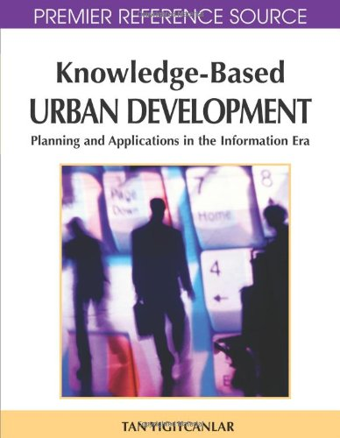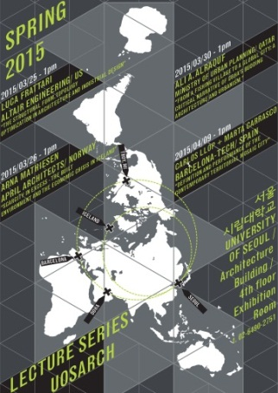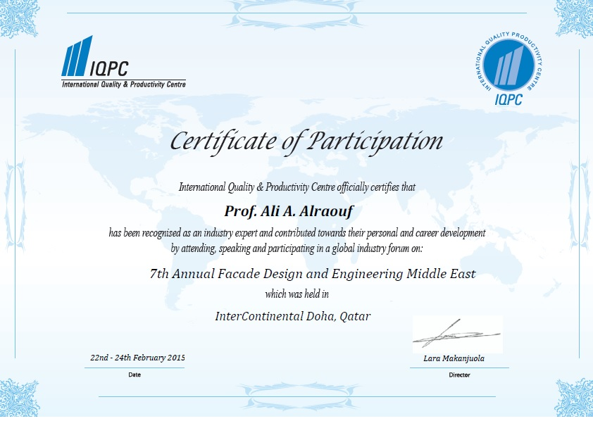
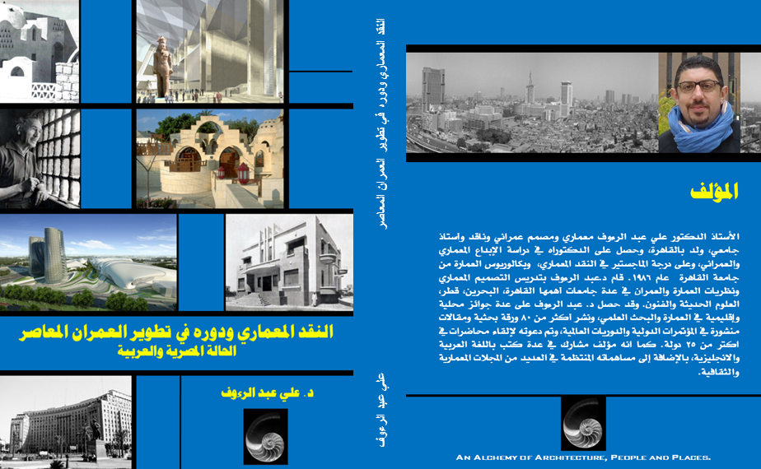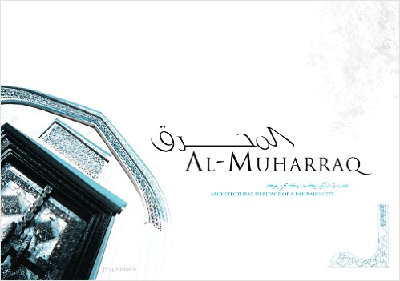
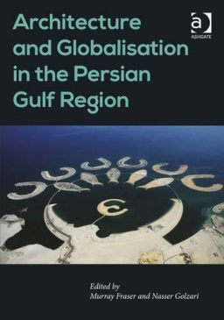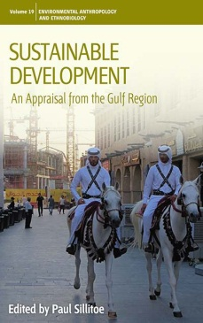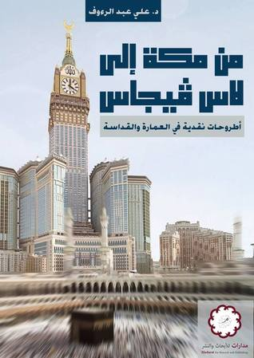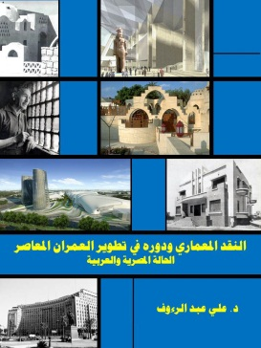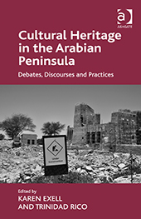
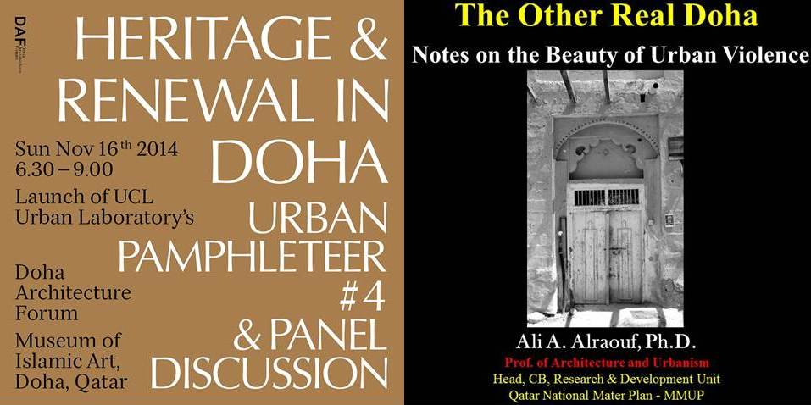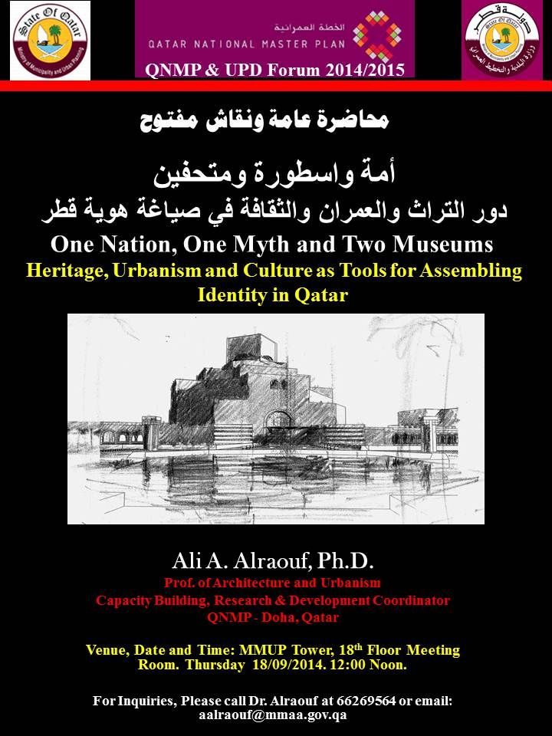

ALI ABD ALRAOUF, Ph.D
Professor of Architecture and Urbnaism
Head of Training and Development at QNMP- Doha
aalraouf@mmaa.gov.qa
aalraouf@mmup.gov.qa
http://analchemyofarchitecture.blogspot.com/
http://qu.academia.edu/AliAlraouf
Overview Ali A. Alraouf, Ph.D., M. Arch., B. SC.

Ali A. Alraouf is an architect, urban designer and planner interested in research and practice related to architectural, urban and comprehensive sustainable architectural design and planning. He is focusing on researches within the domain of theory, criticism and creativity in architecture, urbanism and planning theories. He Holds a Ph.D. in architecture (1996) from Cairo University-Egypt and University of California at Berkeley-USA (Joint academic supervision), a Master of architecture (1991), and a Bachelor of architecture (1986) from Cairo University. He was a Visiting Scholar at Center for Environmental Design Research at University of California at Berkeley-USA (1993-1995) and worked closely with Prof. Christopher Alexander and Prof. Nezar Alsyyad. Alraouf has held permanent and visiting teaching and research positions at Cairo University, UC-Berkeley, 6th October University, Fayoum, Modern Sciences and Arts University (MSA), High Institute of Architecture, University of Bahrain and Qatar University.

Alraouf is a founder and Principal of Environmental design Group (EDG), a consultancy firm, based in Cairo, working in a variety of projects and buildings. He is also a founding member and first chairman of Egyptian Earth Construction Association (EECA), the first Egyptian NGO working in the field of appropriate and sustainable building technologies. Alraouf was a board member of society of Egyptian architects (SEA) and he was chairing the young architects and architectural education committees. Alraouf was Head of architecture dept. at Modern Sciences and Arts University-MSA. In addition, He is working as a consultant for several environmental, planning and architectural projects in Egypt.

Alraouf is a registered architect an urban planner in Egypt, Bahrain and Qatar. He is member of the American Institute of Architects, Middle East and Gulf Chapter. He has practiced for more than twenty years locally and internationally, primarily in Egypt, Bahrain, Qatar, and Saudi Arabia. Since Fall 2004, Alraouf becomes a full-time educator and researcher in the Gulf; he maintained a dynamic level of professional engagement through design competitions and consultancies. Throughout his practice, various competition entries earned prizes, honorable mentions and were selected for public exhibitions. Alraouf’s current research interests are: Contemporary architectural education, The place of children in contemporary Arab cities, Sustainable architecture and urbanism, Urban vitalization of historical districts, The Impact of globalization on the built environment, Traditional smart buildings, Knowledge cities and contemporary Gulf cities’ urbanism.
Alraouf writes extensively in newspapers, periodicals and architectural magazines locally and internationally. He published more than 70 journal refereed papers, critical reviews, essays, in addition to books and book chapters. He is the recipient of innovation award in environmental and sustainable planning from Ministry of scientific research in Egypt 2000, Modern Science and Arts University (MSA) Teaching Excellence Award 2004, Best Research Paper in Sharjah International Conference for Urban Planning 2008 and Research Publication Achievement Award from University of Bahrain 2009. Alraouf was selected as member of 2012 Excel campaign at Qatar University.

Education

Date | Institution | Degree
1991-1996 | Cairo University-EGYPT &  University of California at Berkeley-USA  (Joint academic program & supervision) | Doctor of Philosophy in Architecture.  First dissertation to discuss the topic of creativity in architecture among Egyptian and Arab researchers.
1989-1991 | Cairo University-EGYPT | Master of Science in Architecture.  First thesis to discuss the topic of architectural criticism among Egyptian and Arab researchers.
1987-1988 | Cairo University-EGYPT | Postgraduate studies in Architecture (History, Theory and Criticism)  Overall Grade: Excellent.
1981-1986 | Cairo University-EGYPT | Bachelor of Architecture.  (Ranked no. 2 out of 122 students).

Academic Experience

Date | Rank
June 2013 | Professor of Architectural Design and Urban Theories.  Research, Development and Capacity Building Head, QNMP.  MMUP, Doha-Qatar
Sept. 2009 | Professor of Design and Urban Theories.  Qatar University.
Jan. 2009 | Professor of Architecture and Urbanism.  Granted by Higher Council of Egyptian Universities. Egypt.
Sept. 2004- 2009 | Department of Architecture.  College of Engineering  University of Bahrain
2003-2004 | Head, Department of Architecture  Modern Sciences and Arts “MSA” University, Cairo, EGYPT
2002 | Associate Professor  Department of Architecture  Cairo University, Cairo-Fayoum, Egypt
2001-2002 | Assistant Professor (Part Time)  Department of Architecture  Institute of Architecture, MUST University, Egypt
1996-2001 | Assistant Professor  Department of Architecture  Cairo University, Cairo-Fayoum, Egypt
1999- 2002 | Assistant Professor (Part Time)  Department of Architecture  6th October University, 6th October City, Egypt
1996-1999 | Assistant Professor  Department of Architecture  Cairo University, Cairo, Egypt
1993-1995 | Visiting Scholar  College Of Environmental Design  University of California At Berkeley, USA
1991- 1993 | Lecturer  Department of Architecture  Cairo University, Egypt
1986-1990 | Instructor/ Teaching Assistant  Department of Architecture  Cairo University, Egypt

Professional Practice and Employment History

Date | Position
2014- Present | Advisor and Capacity Building Expert  Qatar Museums and UCL-Qatar
2013- Present | Capacity Building, Training and Development Expert  Urban Planning Department. Qatar
2011- Present | Invited Expert - UN-ESCOWA.  Integrated Spatial Strategy for GCC Countries.
2010 - Present | Invited Expert - UN-Habitat  Arab Cities Development Program.
2010 | Building Capacity and Training Consultant.  Qatar National Master Plan (QNMP).  Ministry of Municipalities and Urban Planning.
2005-2009 | Architectural & Urban Design Consultant  Applied Research Unite, Scientific Research Deanship. University of Bahrain.  Hawar Islands’ sustainable development planning project.
2008 | Technical Committee Member  UNESCO World Heritage Program  Bahrain Cultural and National Heritage Sector.
2007-2009 | Technical Committee Member  Conservation and Rehabilitation of Local Heritage Sites.  Cultural and National Heritage Sector, Bahrain
1989-2004 | Founder & Principal  Environmental Design Group (EDG)  Full Consultancy Provider in the fields of interior design, architectural, environmental and urban design (See Appendix 1).
2002-2004 | Research Team Leader  Center for Housing Research (CHR)  Ministry of Housing, EGYPT
1996-Present | Architecture and Urban Design Consultant  General Organization for Physical Planning (GOPP)  Ministry of Housing, EGYPT
1996-1997 | Head of Design Firm.  Consultancy Group, GB & Associates.  Egypt & Germany.
1998-Present | Architectural & Environnemental Design Consultant  Egyptien Environnemental Affaires Agency (EEAA).  Ministry of Environment, EGYPT
1986-1989 | Architectural Designer.  Community Design Collaborative (CDC)  Cairo & California.

Academic Activities

A- TEACHING (1986-2016).
Throughout twenty six years of teaching, Ali A. Alraouf has taught a variety of courses and design studios. The focus of his teaching experience is on history, theory and criticism. Alraouf has taught architectural and urban design studios at both the undergraduate and the graduate level, in addition to theory seminars, a variety of electives, and directing thesis and graduation projects. His student works have been recognized with awards and exhibitions. The following is a list of courses taught during the last 15 years:

Introduction to Architecture. | Visual Training and Form Composition.
Theories of Architecture I & II. | Research Methodologies.
Principles of Design. | Architectural Graphics I & II
History of Contemporary Architecture. | Design Psychology.
Urban Design | Theories of Design and Urban Planning
Introduction to Urban Design. | Principles of Public Buildings’ Design.
Sustainable Architecture and Urbanism. | Cultural, Social and Behavioral Factors in Architecture and Urban Design.
History of Islamic Architecture. | History of Art Movements.
History of Egyptian Architecture. | Vernacular Architecture.
Knowledge and Creative Cities. | Contemporary Gulf Cities.
History of Urban Design and Planning. | Architectural Criticism.
Design Studios in Architecture and Urban Design (For All Years). | Graduation Projects in Architecture and Urban Design (Research Stage – Design Stage).

B- Relevant Academic and Teaching Activities:
- Head and member of Graduation projects committee for urban planning program at CAS, Qatar University ( Sept. 2009- June 2012).
- Member of Accreditation Committee of Urban design and Planning Program at CAS, Qatar University (2009-2010).
- Member of Faculty Activities Committee at CAS, Qatar University (2010-2012)
- Member of NAAB (Substantial Equivalency) accreditation committee at University of Bahrain (2007-2009).
- Member of Council of Architecture Department, University of Bahrain (2004-2009).
- Member of Planning, Recruitment and Development. Architecture Department, University of Bahrain (2004-2008).
- Organizer and supervisor of scientific trips for students of architecture at University of Bahrain (2004-2009)
- Organizer and Coordinator of Prof. Basiem Hakeim, Prof. Jameel Akbar and Prof. Eckhard Gerber Scientific Visits and Public Lectures at University of Bahrain.
- Member of Architectural Education Development Committee, Supreme Council of Egyptian Universities.
- Head of Architecture Board of Study, Modern Sciences and Art University (MSA).
- Academic and Research Supervisor for a Variety of Master theses and Ph.D. Dissertations.
- Head of Student Advisory Board, Fayoum Campus, Cairo University.
- Member of Education Quality Assurance Committee, at Bahrain, Cairo and MSA Universities.
- Main Coordinator for Lecture Series at Cairo-Fayoum, MSA and Bahrain Universities.
- Editor in Chief for architecture Department Magazine, Cairo University, Fayoum Branch.
- Organizer of the Annual Architectural Exhibition for Students’ Work at Cairo- Fayoum, MSA and Bahrain Universities.
______________________________________________________________________________

Research and Publications

Local, Regional & International Conferences: Published Papers in Conference Proceedings:
Alraouf, Ali. 2016. Branding Qatar via Doha’s Emerging Knowledge-based Smart Urbanism. Arab Future Cities Summit. April 10-12th, 2016.
Alraouf, Ali. 2016. The Creative Urban Chaos in Transforming Arab Cities: The Case of Cairo (In Arabic). Arab Center for Research and Policy Studies. 5th Annual Conference. March 12-14th 2010.
Alraouf, Ali. 2015. Branding Qatar via Doha’s Emerging Knowledge-based Smart Urbanism. Arab Future Cities Summit. April 13-14th, 2015.
Alraouf, Ali. 2015. Towards a Holistic Approach to Sustainability: Heritage, Architecture and Culture as Tools for Assembling Identity in Qatar. Qatar Green Building Conference organized by Qatar Green Building Council. 27-28 April 2015.
Alraouf, Ali. 2015. From Skin to Brain: Dissecting the Move Towards Knowledge-based Façades in Qatar. 7th Annual Façade Design and Engineering Middle East, 23-24 Feb. 2015
Alraouf, Ali. 2015. Interrogating Qatar’s Urbanity as a Catalyst for Building Knowledge-Based Societies and Economies. Gulf Research Meeting. University of Cambridge. 24th-27th August, 2015.
Alraouf, Ali. 2013. Claim Your Midan, From the Sacred to the Profane: Shifts in the Mental and Visual Image of Midan Al Tahrir. International Conference “Arab Revolutions and Beyond: Change and Persistence”. Tunis, November 12 – 13, 2013.
Alraouf, Ali. 2013. Urbanism, Multiculturalism and Islam. The First World Assembly of Islamic Cities which shall be held in Qazvin and Tehran on Aug31-Sep1, 2013.
Alraouf, Ali A. 2013. Revisiting the Role of Architects and Urban Designers: Notes on Mosquephobia. The First World Assembly for Muslim Cities. Organized by UN-Habitat and Qazvin City. Qazvin, Iran. 1-2 Sept. 2013.
Alraouf, Ali A. 2013. Doha, A New Emerging Urban Brand - Gulf Cities as Interfaces. The Fourth Gulf Research Meeting. Gulf Research Centre, Cambridge (GRCC) and the University of Cambridge. 2-5 July 2013.
Alraouf, Ali A. 2013. Reexamine Heritage Conservation In The Gulf: The Case of Doha and Manama. Urban Heritage in Qatar Conference. Organized By University College-London. Doha, Qatar. 23-25th April. 2013.
Alraouf, Ali A. 2012. The Myth of Urban Diversity in the Gulf. 13th conference of the international association for the study of traditional environments (IASTE, UC-Berkeley). Portland, USA. 15-18 Oct. 2012.
Alraouf, Ali A. 2012.The Paradox of Urban Conservation in the Gulf: A Tale of Two Traditional Souqs. The Gulf Studies Conference. Centre for Gulf Studies, Institute of Arab and Islamic Studies, University of Exeter. 17–20 July 2012.
Alraouf, Ali A. 2012. Contemporary Gulf Cities' Urbanism: The Dilemma of Unsustainable Developments and Energy Conservation. The Third Gulf Research Meeting. Gulf Research Centre, Cambridge (GRCC) and the University of Cambridge. 11-14 July 2012.
Alraouf, Ali A. An Emerging Urbanity in Knowledge Economy Paradigm: The Case of Doha, Qatar. International Conference on Realigning Power Geometries in the Arab World. Leibzig University, Germany. 24-26 February 2012.
Ali A. Alraouf. 2012. From Fishing Village to Knowledge City: Sustainable Qatar Urbanity in a Post-carbon Paradigm. Proceedings of The Eighth International Conference on Environmental, Cultural, Economic and Social Sustainability. University of British Columbia, Vancouver, Canada. 10 -12 January 2012.
Alraouf, Ali A. 2011 Assembling Identity for an Emerging Urbanity. Doha, Qatar, as a Creative City. The City: 2nd International Conference. "The City: Culture, Society, and Technology." Vancouver, British Columbia. Canada. 4-6 May 2011.
Alraouf, Ali A. Constructing Future Utopia: A New Paradigm in Knowledge-Based Urban Development, The Case of Doha, Qatar.12th conference of the international association for the study of traditional environments (IASTE, UC-Berkeley) 2010. American University of Beirut, Lebanon. 15-18 December 2010.
Alraouf, Ali A. Doha as a Model for Knowledge and Creative City in the Middle East. Qatar Foundation Annual Research Forum. Doha, Qatar.12-13 December 2010.
Alraouf, Ali A. From Knowledge to Creativity Economy, Qatar Urbanity Transformed. Third Knowledge Cities Summit (KCS) 2010. Melbourne, Australia. 16-19 November 2010.
Alraouf, Ali A. “Critical Paradigms in Analyzing Contemporary Gulf Cities” Technology & Sustainability in the Built Environment, organized by college of Architecture and Planning at King Saud University. 3-6 January 2010.
Alraouf, Ali A. “From Sand to Silicon: Middle Eastern Contemporary Knowledge Cities: The Unfolding Story”. The Second Knowledge Cities Summit. Shenzhen, China. 5-7 November 2009.
Alraouf, Ali A. “Towards a Holistic Sustainability in Contemporary Gulf Cities: A critical Reading”. International Conference for Urban Sustainable Development. United nations & UN-Habitat. Qazvin, Iran. 1-5 Dec. 2009.
Alraouf, Ali A. Regenerating Urban Traditions in Bahrain Learning From Bab Al-Bahrain: The Authentic Fake. IASTE Conference “Interrogating Tradition” Oxford, United Kingdom 12-15 Dec. 2008.
Alraouf, Ali A. “One Decade: Three Paradigms, From Iconic Developments to Sustainable Bubbles: Gulf Cities Transformed”. 5th Great Asian Streets Symposium. Department of Architecture, School of Design and Environment. National University of Singapore. 5 to 7 December 2008.
Alraouf, Ali A. “The Dilemma of Open Spaces in Cairo’s Historic Centres: The Case of Al-Azhar Park & Al-Houd Al-Marsoud - A Tale of Two Parks”. ICOMOS International Scientific Symposium. Quebec, Canada. September 29 - October 4, 2008.
Alraouf, Ali A. “Towards a New Role for Architects in Earthquakes Disasters Locations.” Disasters Management and Buildings’ Safety Conference. Riyadh, Saudi Arabia. 12-15 January 2008.
Alraouf, Ali A. “The Dilemma of Sustainable Architecture in Gulf Cities. Unsustainable Developments and Energy Conservation”. International Conference on Energy Conservation. Kingdom of Bahrain 16 - 18 June 2008.
Alraouf, Ali A. “Globalized/Hybrid Urbanism in Island of Bahrain” 2rd International Symposium (Medi–3ology2)Co stal Settlements, Culture, and Conservation in the Mediterranean Basin, Dec. 8-10, 2007 Cyprus.
Alraouf, Ali A. “Vertical Gated Communities: The Case of Al-Juffair Al-Jadidh, Bahrain”. 3rd Housing International Symposium, Riyadah, Saudi Arabia. 23-26 March 2007.
Alraouf, Ali A. “Hybrid Urbanism in Bahrain: From Pearl Hunting to Pearl Making: The Story of Iconic Development in Bahrain” IASTE 2006 Conference, “Hyper – Traditions”. Dec. 15-18, 2006. Bangkok, Thailand.
Alraouf, Ali A.“The Impact of E-Learning on Architectural Education”. First International Conference of the E-learning Center at University of Bahrain. Kingdom of Bahrain. April 17-19, 2006.
Alraouf, Ali A. “Territorial Outlook of Arab/Gulf Cities Transformed”. The 9th Sharjah Urban Planning Symposium (SUPS 9). Sharjah, United Arab Emirates. April 2-4, 2006.
Alraouf, Ali A. “Dubaization vs. Glocalization: Arab Cities Transformed”. Gulf First Urban Planning and Development Conference. Kuwait. Feb.22-24, 2006.
Alraouf, Ali A. “The Origins of Smart Architecture: Reinterpreting Traditional Intelligent Buildings and Spaces”. Intelligent Building-Middle East 2005. International conference for Buildings Concepts, Materials and Technologies. Manama, Kingdom of Bahrain. December 5-7, 2005.
Alraouf, Ali A. “Knowledge Cities: Examining The Discourse, Smart Villages, Internet Cities or Creativity Engines”. International Symposium on Knowledge Cities. Al-Madina Al-Munawara, Saudi Arabia -November 28-30, 2005.
Alraouf, Ali A. “Authentic Images vs. Global Icons: A critical Search for Identity in Cairo’s Contemporary Architecture”. XXII World Congress of Architecture. Cities: Grand Bazaar of ArchitectureS, UIA 2005 Istanbul, Turkey 3-10 July. 2005.
Alraouf, Ali A. The 5th Conference of the College of Education. “Quality of Higher Education” Manama, Kingdom of Bahrain.11-13 April, 2005.
Alraouf, Ali A. “Back Street Boys: Towards A Place For Children In Today’s Arab Cities.” The 8th Sharjah Urban Planning Symposium (SUPS). Sharjah, United Arab Emirates. April 3-5, 2005.
Alraouf, Ali A. The 23rd Arab Engineering Conference. Manama, Kingdom of Bahrain. 14-16 March, 2005.
Alraouf, Ali A. “No More Fear od Doubt, Electronic Architecture and Architectural Education” First international Conference on Computer Aided Architectural Design, At King Fahad University (KFUMP) Damam, Saudi Arabia, 22-24 Feb. 2005.
Alraouf, Ali A. “Towards a New Vision of Globalization Dilemma and the Challenges of Local Reality” in “Post Traditional Environments in Post Global World” IASTE’s (UC- Berkeley) international Conference American University in Sharjah, United Arab of Emirates. 14-18 Dec. 2004.
Alraouf, Ali A. “The Ghost Dance of Architecture: Redefining Authenticity in Digital Architecture” in “Post Traditional Environments in Post Global World” IASTE’s (UC- Berkeley) international Conference American University in Sharjah, United Arab of Emirates. 14-18 Dec. 2004.
Alraouf, Ali A. “Heritage, Globalization and the Built Environment” 1st international Conference of Bahrain Society of Engineers and University of Bahrain, Bahrain. 6-8 Dec. 2004.
Alraouf, Ali A. “Contemporary Arab House: urban and Architectural Patterns” 2nd international Housing Symposium Riyadh, Saudi Arabia, 28-31 March 2004
Alraouf, Ali A. “Electronic Spaces And Urban Places: Sustainability Or Challenge? ”1st National Architectural Conference of Department of Architecture at Cairo University on Architecture, Urban and Sustainable Development. 26-28 Feb. 2004.
Alraouf, Ali A. “The Role of Sustainable Architecture in Preserving and Developing Egyptian protectorates” 1st National Architectural Conference of Department of Architecture at Cairo University on Architecture, Urban and Sustainable Development. 26-28 Feb. 2004.
Alraouf, Ali A. “Towards a New Paradigm in Teaching Egyptian Architects” UIA/UNESCO 1st International conference on architectural Education in the Third Millennium. Bibliotheca Alexandrina. Egypt. 8-10 March 2003.
Alraouf, Ali A. “Critical issues of Contemporary Egyptian Architecture” Society of Egyptian Architects’ annual conference. Cairo, Egypt. December 2002.
Alraouf, Ali A. “Desert Language: urban and architectural patterns”, Symposium on Urban Development in Arid Regions & associated Problems. Riyadh, Saudi Arabia, 2-4 November 2002.
Alraouf, Ali A. “Critical Review of Gamal Bakry’s Architecture”, Egyptian Ministry of Culture, Architectural committee annual meeting, Cairo. Dec. 2001.
Alraouf, Ali A. “The Concept of Creativity in Contemporary architectural Education”, Conference of architectural Education in the Mediterranean. Antalya- Turkey Nov. 2001.
Alraouf, Ali A. “The role of architectural education in documenting and preserving architectural heritage” Cairo University, 3rd annual conference, Cairo, May 2001.
Alraouf, Ali A. “Urban and Architectural Development of St. Katherine Protectorate”, the second international conference of environmental technologies and management. Cairo, Nov. 1999.
Alraouf, Ali A. “Manufacturing Heritage: Development, preservation and tourism in the age of globalization, International association for the study of traditional settlements, UC-Berkeley, USA> Dec. 1998.
Alraouf, Ali A. “Appropriate Building Technologies”, Egyptian Earth Construction Association (EECA), Cairo, Dec. 1997.
Alraouf, Ali A. “The Role of Architectural Education in Enhancing the Environmental Awareness Of Future Architects”. 4thINTERBUILD,Cairo, June 1997.
Alraouf, Ali A. “Architectural Creativity and building regulations”, Egyptian Ministry of Culture, Architectural committee annual meeting, Cairo. Dec. 1996.
Alraouf, Ali A. “Environmental Planning: An Approach Towards Preserving Natural Protectorates”. 3rd INTERBUILD, Cairo, June 1996.
Alraouf, Ali A. “Green Architecture: Towards a Definition”, Environmental Studies Institute, Cairo, April 1996.
Alraouf, Ali A. “Vernacular Architecture Forum” Charleston, South Carolina .USA May 1994.
Alraouf, Ali A. “Critical Issues of Practice” College of Architecture, Cincinnati, Ohio USA. Oct. 1994.

B- Published Papers in International Refereed Journals:
Alraouf, Ali. 2016. Creative Urban Chaos, The Case of Cairo. Omran Journal for Social and Human Sciences. Published by Arab Center for Research and Policy Studies. Issue: Year 2016 Volume.
Alraouf, Ali. 2016. Critical Reflections. Waly Center for Architecture and Heritage Journal. Feb. issue.
Alraouf, Ali A. 2012. A Tale of Two Souqs. In or Out of Place: The Paradox of Gulf Urban Diversity. Open House International Journal. Volume 37, Issue No. 2, June 2012. pp:72-81.
Alraouf, Ali A. 2011 Islam and Arabs, Identity and Globalization: Challenges and Transformations in Contemporary Gulf City. In Art and Architecture Research and Design Magazine (Lonaard). London, UK Vol.1 Issue 4. July 2011. Pp: 68-84. ISSN: 2045-8150.
Alraouf, Ali A. 2011. Mosquephobia: The dilemma of Architecture, Multiculturalism and Islam. Art In Art and Architecture Research and Design Magazine (Lonaard). London, UK Vol.1 Issue 3. May 2011. Pp: 78-88. ISSN: 2045-8150.
Alraouf, Ali A. 2011. Museums’’ Architecture and Urbanism as an Educational Tool, The Case of Museum of Islamic Art, Doha, Qatar. Education Reform Journal, Tawasol. Issue 13. Fall 2010. Pp: 17-28.

Alraouf, Ali A. 2010. Islam, Culture, and Community: The Role of Museums’ Architecture and Urbanism, Museum of Islamic Art, Doha. Journal of Islamic Architecture, Vol. 1 Issue 2. Pp:60-69. ISSN: 2086-2636.
Alraouf, Ali A. 2011. Architecture and Urbanism Education, New Trends and Visions Tawasol Educational Reform Journal. Doha, Qatar. Fourteenth Issue - Spring 2011. Pp:3-12.
Alraouf, Ali A. “Regenerating Urban Traditions in Bahrain”. in Journal of Tourism and Cultural Change (JTCC). Published By: Routledge. USA. Vol. 8. Issue: 1-2. 2010. Pp: 50-68. ISSN: 1476-6825.
Alraouf, Ali A. “Towards a Safe place for children in today’s residential Neighborhoods”. Journal of the Malaysian Institute of Planners (IMIP), Malaysia, pp: 57-73. March 2008.
Alraouf, Ali A. “Learning From Bab Al-Bahrain: The Authenticity of Fake.” Journal of Art and Architecture Winter 2007 Issue 4. pp:17-22.
Alraouf, Ali A. “Hybrid Urbanism in Bahrain: From Pearl Hunting to Pearl Making: The Story of Iconic Development in Bahrain” in Traditional Dwellings and Settlements Review. Journal of the International Association for the Study of Traditional Environments., USA. Issue 01- Fall 2006. pp: 28-41. ISSN: 1050-2092.
Alraouf, Ali A. “Planning Middle Eastern Cities: An Urban Kaleidoscope”. Book Review in Arab Studies Journal (ASJ), USA. Fall 2006 (Vol. XIV No. 2). pp: 111-116.
Alraouf, Ali A. “Intelligent Buildings in the Middle East: The Origins of Smart Architecture” (Text in English and German) in Intelligente Architektur (Intelligent Architecture) Journal, Germany. (Vol. 01 - Issue 03), 2006.
Alraouf, Ali A. “Dubaization: The Emergence of New Urban Brand in the Middle East” In Journal of Cultural Exchange (Kultur Austausch), Germany. (Issue III), 2006. pp: 25-31.
Alraouf, Ali A. “Desert Language: Principles and Patterns for Architecture”. In Al-Omran Magazine. Published by the Department of Architecture at the Islamic University in Gaza, Palestine (Vol. I- Issue 06).
Alraouf, Ali A. 2006 “Knowledge Cities: Examining the Discourse, Smart Villages, Internet Cities or Creativity Engines”. Journal of the Malaysian Institute of Planners (IMIP), Malaysia Vol. (4) -2006. pp: 31-48.
Alraouf, Ali A. “The Ghost Dance of Architecture: Redefining Authenticity in Digital Architecture?” co-authored with Khairy, H. in the Traditional Dwellings and Settlements Working Paper Series. Volume 174: (Global Networks), 2004.

Published Books and Book Chapters

Alraouf, Ali. 2016. Museums as a Catalyst for a New Urban and Cultural Identity in Qatar Interrogating the Case of Museum of Islamic Art. In Museums in Arabia: Transnational Practices and Regional Processes.) . Exell, Karen and Wakefield, Sarina (eds.) (Ashgate: UK, 2016).
Alraouf, Ali. 2016. “Dohaization”: An Emerging Interface between Knowledge, Creativity, and Gulf Urbanity. Pp.: 47-68. In Katodrytis, George and Syed, Sharmeen. Gulf Cities as Interfaces. Cambridge: Gulf Research Centre Cambridge.

Alraouf, Ali A. 2014. Alraouf, Ali. 2014. The rehabilitation of the Muharraq historical center, Bahrain: a critical narrative. In Cultural Heritage in the Arabian Peninsula. Karen Exell and Trinidad Rico (eds.). London: Ashgate.
Alraouf, Ali A. and Clark, Sarah. 2014. From Pearls to Towers, The Dilemma of Sustainable Architecture and Urbanism in Contemporary Gulf Cities. Book chapter in Paul Sillitoe (ed.) “Sustainable Development: an introduction focusing on the Gulf region”. (Oxford: Berghahn Books).
Alraouf, Ali. 2014. From Mecca to Las Vegas: Critical Reflections on Architecture and The Sacred. Cairo: Madarat for Research and Publications. Cairo, Egypt.
Alraouf, Ali A. 2013. Manama, Bahrain. Book chapter in “Architecture and Globalization in The Persian Gulf Region. (Eds. Murray Fraser And Nasser Golzari). London: Ashgate.
Alraouf, Ali A. 2012. Qatar and Bahrain Cities. Book chapter in “State of The Arab Cities”. Published by United Nations Habitat, New York, USA.
Alraouf, Ali A. 2010. “ Education for sustainable development in higher education: the experience of Gulf Universities” Book chapter in Tomorrow Today, UNESCO (London: Tudor Rose). ISBN: 0-9536140-85.
Alraouf, Ali A. chapter author titled “The Triology of Derrida, Deconstruction and Architecture” in “Jack Derrida, Retrospect” Al Banki (ed.) Published by Ministry of Culture and Information, Kingdom of Bahrain. 2009. PP: 104-117. ISBN 978-99958-0-072-7. http://www.daralhayat.com/print/82694
Alraouf, Ali A., chapter author titled “Knowledge Based Urban Development: Planning and Application in the Information Era”. Tan Yigitcaular & V. Koray (eds.) Ali A. Alraouf, Chapter Author. IGI Global Publishing, USA www.igi-global.com 2008. Pp:240-259. ISBN No: 13:978-1-59904-720-1.
Alraouf, Ali A. “Knowledge Cities: The Future of Cities in the Knowledge Economy”. Edited Volume (Co Author). (SP) Scholar Press, Kula Lambur, Malaysia. 2007. ISBN No: 978-983-3813-17-9.
Alraouf, Ali A. “Al- Mouharraq- Architectural Heritage of A Bahraini City”. Full Arabic Translation and Editing. Original text by John Yarwood and English editing by Sohail El-Masri.. Published by Ministry of Information and Culture. Kingdom of Bahrain. 2005. ISBN No: 99901-37-19-6.
Alraouf, Ali A. “Towards a New Paradigm in Architectural Education” Co-authored, Published by Union of Mediterranean Architects (UMAR). Turkey 2001.
Alraouf, Ali A. “Architecture of Theaters: The Case of Al-Baloon Theater” Co-authored Pp:29-50, Published by Ministry of Culture, Egypt 1999.
Alraouf, Ali A. Development Strategy for Fayoum Governorate.” Co-authored with distinguished team of Cairo University Professors, published by Information center of cabinet of ministries, Cairo 1998.
Alraouf, Ali A. Encyclopedia of Architectural Creativity (Three Vol.) Co-authored with Prof. Ali Raafat, published by Inter-consult research center, Cairo 1997.

D- Articles (Periodicals, Journals, Magazines and Newspapers)
Alraouf, Ali A. 2012. Al-Doha Cultural Magazine. The Architecture of Doha (In Arabic). Published by Minister of Culture, Qatar. Vol. December Issue.
Alraouf, Ali A. 2012. Al-Doha Cultural Magazine. The Wall(In Arabic).. Published by Minister of Culture, Qatar. Vol. August Issue.
Alraouf, Ali A. 2012. The Drama of Fisherman Hut’s Architecture in Bahrain. Al Bennaa Magazine. June 2012 Vol. 32, Issue 260. Pp:94-100.
Alraouf, Ali A. 2012. Al-Doha Cultural Magazine. The City and Colors (In Arabic).. Published by Minister of Culture, Qatar. Vol. June Issue.
Alraouf, Ali A. 2012. When They Will Declare the Death of the Pharos.AESPlusM Magazine. Vol. 1 issue 9. Issue July 2012. Pp:32-45.
Alraouf, Ali A. 2012. The Culture of Coincidence and The Issue of Identity:The Drama of Fisherman Hut’s Architecture in Bahrain.AESPlusM Magazine. Vol. 1 issue 8. June 2012. Pp:15-29.
http://www.aecplusm.com/download/201206/bah/bah.htm
Alraouf, Ali A. 2012. City, Architecture and Color: Towards a Humanistic Dialogue. AEC plus Magazine for Architecture and Construction. Vol. 1, issue 7. PP: 15-19. N.Y., USA.
http://www.aecplusm.com/download/201205/cac/cac.htm
Alraouf, Ali A. 2012. Al-Doha Cultural Magazine. The Wall. Published by Minister of Culture, Qatar. Vol. Issue. Pp: .
Alraouf, Ali A.. 2012. Al-Doha Cultural Magazine. The City, the Colors. Published by Minister of Culture, Qatar. Vol. Issue. Pp: .
Alraouf, Ali A. 2011. From Coca Cola to City: Concepts in Urban and Architectural Marketing. Al-Arab newspaper, Qatar. Issue: 8350 published April 23, 2011. P:8.
Alraouf, Ali A. 2011. Souq Waqif as a representation of Qatar’s Heritage Preservation. Al-Arab newspaper, Qatar. Issue: 8324 published March 24, 2011. P:12.
Alraouf, Ali A. 2011.The Story of People and Midan: Urban Reflections on Liberation Issue. Al-Arab newspaper, Qatar. Issue: 8287 published February 19, 2011. P:23.
Alraouf, Ali A. 2010. The Status of Qatar Architecture and Urbanism. Al Raya newspaper, Qatar. November 2010.
Alraouf, Ali A. “Towards Children Friendly Cities in Bahrain” in Gulf News. 28 Feb. 2009 p:12.
Alraouf, Ali A. “Public Lectures: A new Knowledge Window”. In Gulf News.. 6 June. 2007.
Alraouf, Ali A. “Public Buildings in Egypt: Critical Reflections”. Al Benaa Architectural Magazine, Saudi Arabia. Issue 204. Oct. 2007. Pp:31-36.
Alraouf, Ali A. “Towards a New Vision For Architectural Education in University of Bahrain”. In Gulf News.. 12 Feb. 2006. P:18.
Alraouf, Ali A. “Contemporary Reading For Architecture of Bahrain”. Al Benaa Architectural Magazine, Saudi Arabia. Issue 185. Feb. 2006. Pp:116-123. Co author with Sohail El-Masri, 2006.
Alraouf, Ali A. “The Architecture of the Outsider: The Case of New Juffair Residential Area, Manama”. In Akhbar Al-Khalieg. 4 Feb. 2005.
Alraouf, Ali A. “Egyptian Architecture: Today and Tomorrow” Albenaa Arch. Magazine, issue no: pp70-71 April 2001.
Alraouf, Ali A. “Towards a New Era in Hassan Fathy’s Architecture” Albenaa Arch. Magazine, issue no: pp 60-62 April 2001.
Alraouf, Ali A. “Residence Of Egyptian Ambassador in Berlin: A Critical Analysis” Albenaa Arch. Magazine, issue no: pp 66-68 April 2001.
Alraouf, Ali A. “Contemporary Egyptian Architecture: Issues and Trends” Albenaa Arch. Magazine, issue no: pp 25-27 April 2001.
Alraouf, Ali A. The Rise of Knowledge: Alexandria Biblioutiq Between Sydney Opera And Bilbao museum. Benaa Magazine pp:28-37 Apr. 2001
Alraouf, Ali A. “Contemporary Architecture in the Age of Information Technology” Albenaa Arch. Magazine, issue no: pp 50-53 April 2001.
Alraouf, Ali A. “Architectural Building as a Media For Cultural Dialogue” Albenaa Arch. Magazine, issue no: pp 54-57 April 2001.
Alraouf, Ali A. “Towards a methodology for the criticism of contemporary Egyptian Architecture” Alam Albenaa Arch. Magazine, issue no:208 Feb. 1999.
Alraouf, Ali A. “Towards An Environmentally Correct Architecture” Alahram Newspaper; 21 Jan.1998.
Alraouf, Ali A. “On Architectural Competitions” Alahram Newspaper March.1998.
Alraouf, Ali A. “The Theoretical Responsibility of Egyptian Architects: Reflections on The Encyclopedia of Architectural Creativity.” Alahram Newspaper 24 June 1997.
Alraouf, Ali A. “The Role of Egyptian Architectural Committee” Alahram Newspaper Jan.1997.
Alraouf, Ali A. “The Wall and The Garden: On Egyptian Public Spaces” Alahram Newspaper Oct.1996.
Alraouf, Ali A. “Architectural Creativity Between professional mediocrity and richness of the primitive” Alahram News paper Aug.1996.
Alraouf, Ali A. “Historical Buildings in Cairo’s Urban Fabric: The Case of Al Harawy House” Alahram News paper Aug.1996.

E- Unpublished Theses
- “Architectural Criticism and its Role in Developing Contemporary Egyptian Architecture” Unpublished Master Thesis, Cairo University 1991.
- “Collective Creativity in Architecture: Towards a Holistic approach Towards the Enhancement of the Built Environment” Unpublished Ph.D. Dissertation, (In English) University of California At Berkeley and Cairo University 1996.
F- Electronic Publishing:
- The following list is showing the articles which were digitally published, in Arabic, on the World Wide Web in the most important Arabic architectural site www.arabarch.net.

G- Sponsored Publications and Professional Reports
Alraouf, Ali A. 2009. “The Impact of Globalization on Today’s Cities of Bahrain: Evaluating Bahrain Hybrid Urbanism”. University of Bahrain.
Alraouf, Ali A. 2007. “Principles, Concepts, and Design Guidelines for Children Architecture and Urban Design” University of Bahrain.
Alraouf, Ali A. 2005. “Educational Buildings in Egypt: A Comprehensive Design Matrix for Schools Design” National Research Center, Ministry of Housing, Egypt.
Alraouf, Ali A. 2005. “Design Principles and Guidelines for Schools in Egypt” Technical report, (In Arabic) Ministry of Housing, Egypt.

H- Course Texts
- Introduction to Urban Design. Qatar University.
- Urban Design and Planning Theories. Qatar University.
- Principles of Public Buildings Design. University of Bahrain
- Social and Cultural and Behavioral Factors in Design. University of Bahrain
- Architecture and Globalization. Modern Sciences and Arts University.
- Architectural Criticism. Cairo University.
- Introduction to Theories of Architecture I and II. Cairo University.

Graduate Supervision and Examination

Supervision of Ph.D. and MA Theses
- Elisabeth Schein, “Built on Sand? Emerging Cities on the Arabian Peninsula in the Context of Knowledge-Intensive Economies”, Local Advisor. PhD Dissertation. Munich University of Technology., Germany 2009.
- Salah Abdullah Rashid, Architecture and Music: The Creative Relationship, MA Theses, Cairo University. Egypt 2005.
- Islam Alsamahy. The Effect of New Architectural Design Process on Contemporary Form & Function. MA Theses, Faculty of Fine Arts, Dept of Architecture. Alexandria University., Egypt 2005.
- Essam Abdel Alim, Cultural Dimensions in Public Spaces: Towards an alternative vision for Public spaces in Egypt., PhD Dissertation, Cairo University, Egypt 2002.
- Graduation Project Design Theses.
Academic External Examiner for:
- Amany Badr, Sustainability in Multistory Buildings, MA Theses, Faculty of Fine Arts, Dept of Architecture. Alexandria University., Egypt 2004.
Academic External Examiner (Jury Member) for:

Oregon University. Architecture and Urban Studio supervised by Prof. Howard Davis and Prof. Hajo Nies. Fall 2012.

Drury University, Hammonds School of Architecture. Community-based Studio supervised by Jay G. Garrott, AIA. Professor of Architecture, Director of the Center for Community Studies. Fall 2012. 16th Oct. 2012.
  - Al Al-Bait University. School of Architecture and Planning. Graduation projects. Academic year 2008/2009.
  - University of Jordan, Department of Architecture. Graduation projects. Academic year 2007/2008.
  - Promotion for Associate Professor in Architecture. College of Architecture and Planning. King Saud University - Arriyadh, Saudi Arabia. 2007.
  - Center for the Study of the Architecture in the Arab Region (CSAAR)., Jordon & Saudi Arabia. 2006.
  - Kingdom University, Department of Architecture. Final Design Studio Jury. Bahrain. 2006.
  - American University in Sharjah (AUS). Design Studio VI Jury. Sharjah, UAE. 2005.
  - University of Alexandria, College of Fine Arts, Department of Architecture. Graduation projects. Academic year 2003/2004.
  - Modern Science and Arts University, Department of Architecture. Graduation projects. Academic year 2003.
  - College of Environmental Design (CED). UC- Berkeley. Environmental Design Studio. 1995.

Participation in Peer Review Process for Conferences and Refereed Journals
- Journal of Traditional Dwellings and Settlements, University of California at Berkeley, USA.
- Journal of Tourism and Cultural Exchange (JTCE).
- Journal of Islamic Architecture (JIA), Advisory Board member and Reviewer.
- Journal of Art and Architecture (Lonaard), Advisory Board member and Reviewer.
- Journal of the Malaysian Institute of Planners (IMIP), Malaysia.
- Journal of King Saud University, Saudi Arabia.
- Journal of King Abdul Aziz University, Saudi Arabia.
- Advisor for Al-Doha Cultural Magazine. Published by Minister of Culture, Qatar. 2012.
- Advisor for Al Bennaa architectural magazine, Saudi Arabia (1999-2002).
- Scientific committee member in a large number of regional and international conferences including IASTE biannual, Intelligent Buildings Conference., International Conference on New Trends in Architectural Education, Sharjah Urban Planning Symposium, Knowledge cities Summit, International Conference on Heritage Conservation and the Gulf Research Meeting. Gulf Research Centre, Cambridge (GRCC).

Seminars, Symposiums, Short Courses and Workshops
“Building Sustainable Communities Seminar”. Organized by British Embassy Doha, Qatar. 23rd January 2012.
“Shaping the Future of Architecture and Urbanism in Islamic Societies” Faculty of Islamic Studies. Qatar Foundation. Doha, Qatar. 21st Dec. 2011.
“God is Beautiful: Islamic Art in 21st Century”. Ministry of Culture, and Virginia Commonwealth University, Doha 29 Oct.- 1st Nov. 2011. Museum of Islamic Art. Doha, Qatar.
Sustainability in Practice. Organized by Qatar Green Building Council. 26th April 2011.
Professional Ethics in a Globalized World: Towards a Unified East-West Perspective. Organized by Texas A & M University and Faculty of Islamic Studies, Qatar. 11-12 May 2011.
“Architecture, Environment and Globalization”. A one day workshop for students of architecture at University of Bahrain. Organized by Student Union at UoB. 17 Nov., 2005.
“Smart Buildings and Smart Cities”. A one day workshop for students of architecture at University of Bahrain. Organized by Student Union at UoB. 27 April, 2006.
“Architecture and Globalization”. A short course designed for architects, urban designers and decision makers Bahrain. Submitted to Center for Continuing Education at UoB.
“Children Architecture”. A short course designed for architects, urban designers and decision makers Bahrain. Submitted to Center for Continuing Education at UoB.

Awards, Design Competitions
- Qatar University Excel Achievements Campaign: Awarded Member in 2012.
- Research Publication Achievement Award. University of Bahrain. 2009.
- Beast Research Paper “The Best Paper” in the 10th Sharjah Urban Planning Symposium (SUPS 10), Sharjah , UAE. 23-25 Nov, 2008.
- Modern Science and Arts University (MSA) Teaching Excellence Award. 2004.
- Egyptian national prize of innovation in the field of environmental and architectural design of natural protectorates, Scientific research Academy, Egypt 2000.
- Full research scholarship at university of California at Berkeley for conducting Ph.D. studies, USA 1993-1995
- Prof. Ali Raafat Prize for excellence in the study of design theories and methods, Department of architecture, Cairo University. 1986
- First Prize in the architectural design competition of the following:
- Arab Housing Proposals 1997
- Beverley Hills Compound 1997
- Head quarters of Ministry of Labor and Social Services, Saudi Arabia 1997
- Ministry of Education’s exhibition in Genadireah, Riyadh 1998
- Wadi Degal Protectorate and Research Center. Cairo, Egypt 2000.
- Second Prize in the architectural design competition of the following:
- Architectural Development of Egyptian Engineering Syndicate 1987
- Urban and Architectural Development of Masbiro Area, Cairo 1995
- Third Prize in the architectural design competition of the following:
- Egyptian national circus 1997
- Headquarters of touristic promotion authority 1998
- Al Kanater Al Khairya’s Palace of Culture 1998

Professional Affiliations
- International Association for the study of Traditional Environments (IASTE), USA.
- Vernacular Architectural Forum, (VAF), South Carolina, USA.
- Member of technical Committee of Heritage and monuments ICOMOS.
- Syndicate of Egyptian Architects and Engineers, Registered Architect, No.3910/9
- Syndicate of Egyptian Architects and Engineers, Registered Architectural Consultant in the design of educational Buildings.
- Architecture Arab Critics, International Advisory Board Member.
- Society of Egyptian Architects, ex. Board Member
- Society of Urban Planning, Egypt.
- Society of Architectural Heritage Conservation, UAE
- Center of Environmental Design and Research, UC-Berkeley, USA
- Egyptian Earth Construction Association (EECA)
- Egyptian Authority for Urban Planning.
- Supreme Council of Culture, Architecture Committee.
Affiliation:
UIA; Union of International Architects
RIBA; Royal Institute of British Architects

Grants and Funded Awards
- Qatar University Research Grant, to support The City international conference participation. . British Columbia, Vancouver, Canada. $ 6000, 2011.
- Qatar University Research Grant, to support The Third Knowledge Cities Summit international conference participation. Melbourne, Australia. $ 6000, 2010.
- University of Bahrain, Dean of Scientific Research University of Bahrain , Dean of Scientific Research. “Studying the Impact of Globalization on Bahrain’s Major Cities”. $12000, 2007-2009.
- University of Bahrain. Dean of Scientific Research Grant, to support IASTE international Conference participation. . Oxford, England. $3500, 2008.
- University of Bahrain Grant, to support ICOMOS international Conference participation. . Quebec, Canada. $4000, 2008
- University of Bahrain, Dean of Scientific Research University of Bahrain, Dean of Scientific Research. Towards A Place for Children in Today’s Cities of Bahrain: Principles, Concepts, and Design Guidelines for Children Architecture and Urban Design. $10000, 2005-2007.
- University of Bahrain Grant, to support UIA Conference participation. $3000, 2005
- Modern Science and Arts University (MSA) Teaching Excellence Award. $1000, 2004
- Egyptian Scientific Research Academy’s National Prize of innovation in the field of environmental and architectural design of natural protectorates, , Egypt $1000, 2000
- British Council in Egypt Fund to support Young Architects Symposium and Exhibition. $3500, 1999.

Public Lectures
On Qatar Emerging Architecture and Urbanism. Arab Academy for Science and Technology (AAST). Nov. 5th, 2012.
From Pearls to FIFA. A Narrative of Doha’s Budding Architecture and Urbanism. Drury University, Springfield MO-USA. Oct. 15th. 2012.
From Pearls to FIFA. A Narrative of Doha’s Budding Architecture and Urbanism. Oregon University. Portland, Oregon-USA. Oct. 10th. 2012.
Gulf Cities: The Contemporary Scene. Portland State University. Oct. 8th. 2012.
Qatar’s New Urban Brand: Critical Issues. Public Lecture for Portland State University Delegation. QU, Qatar. March 25, 2012.
The future of Qatari cities in The Knowledge-based urban Development Paradigm. Public Lecture at Virginia Commonwealth University in Qatar (VCUQ), Education city, Doha, Qatar. 28th Feb. 2012.
Qatar’s Urbanity in an Emerging Middle East: A critical Examination. Harvard University. 19th Sept. 2011.
Pearls, Harrods and FIFA. Doha, The Capital of Qatar. Department of Architecture and Urban Planning, Qatar University. 18th May 2011.
The Evolution of Qatar Architecture and Urbanism: A Critical Review. Public Lecture for Portland State University Delegation. QU, Qatar. March 23, 2011.
Doha as a Creative City: A new Gulf Model. Qatar University. Doha, Qatar. Fall, 2010.
2000-2010: One Decade and Three Paradigms: Gulf Cities Transformed. Vienna University organized by the Austrian Association for the Middle East. Vienna, Austria. 24 November 2010.
Towards a Place for Children in Today’s Cities: Reflections on Gulf & Qatar Cities. Qatar University. Doha, Qatar. Wednesday, April 7, 2010.
Al Imam University, Qazvin, Iran. Public Lecture Titled” Emerging Urbanism in Gulf Cities”. Dec. 2009.
Jordon University, Jordon. . Public Lecture Titled: The Trap of Identity in the Middle East Architecture and Urbanism”. May 2008.
Islamic University, Malaysia. Public Lecture Titled: Knowledge Cities In the Middle East”. July 2007.
King Saud University, Saudi Arabia. Public Lecture Titled: “Architecture and Urbanism in Contemporary Bahrain”. March 2007.
“Environment & Architecture” Rotary Club of Manama, Kingdom of Bahrain. Feb. 2005.
“Sustainable architecture and Natural Protectorates in Egypt” The American University in Cairo (AUC), Cairo. April 2004
“A New Vision for New Generation of Architecture Students” University of Modern Sciences and Arts MSA, Cairo, Oct.2003.
“Young Egyptian Architects: A Critical Review”, British Cultural Council, Cairo May 2001.
“Children Architecture: Concepts and Design Issues”, 6th October University, May 2001
“Architectural Design in the Islamic World Today”, College of Architecture University of British Colombia (UoBC) Vancouver, March 1996.
“Contemporary Egyptian Architecture: People, Religion and Revolution, A Critical Review”, UC. Berkeley, USA. Mar. 1995
“Creative Trends in Contemporary Egyptian Architecture”, UC. Berkeley, USA. Dec. 1994.

Languages
Languages: Arabic and English (Excellent proficiency in reading, writing and conversation).
Computer Use
Windows and MAC platforms and operating systems, Form z, Microsoft Office, AutoCAD, Photoshop, Outlook, PowerPoint, Internet explorer, outlook Express and advanced Black Board.
Interests & Hobbies
Swimming & Tennis; Veteran player in Gezira Sporting Club, Bahrain Tennis Club and Qatar Tennis Federation.
Camping and Desert Traveling.
Photography and Creative Writing.
Travel
During the last two decades, Alraouf traveled to the following countries to participate in international symposiums, seminars, juries and conferences where he was a speaker, keynote speaker, jury member, external examiner and session chair/moderator: Andorra, Australia, Austria, Bahrain, China, Egypt, England, France, Germany, Holland, Iran, Italy, Jordan, Kuwait, Lebanon, Libya, Malaysia, Morocco, North Cyprus, Qatar, Saudi Arabia, Spain, Thailand, Tunisia, Turkey, United Arab of Emirates, USA and Vatican.

References:

Prof. Nezar Alsayyad  Prof. of Architecture and Urbanism.  Chair - Center for Middle Eastern Studies.  UC- Berkeley, USA.  nezar@uclink4.berkeley.edu  001-510.642.6801 | 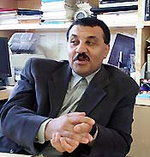
Prof. Hajo Neis.  Prof. of Architecture and Urban Theory..  Oregon University, USA.  hajoneis@uoregon.edu  001-503 412-3731 | 
Prof. Abdelhalim Ibrahim Abdelhalim  Prof. of Architecture and Design Theories  Recipient of Aga Khan Award for Architecture.  halim@cdchalim.com  002-0233474274  Cairo University, Egypt. | 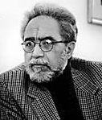
Prof. Suha Ozkan  Former G. Secretary, Aga Khan Award for Islamic Architecture.  World Architecture Chairman  Prof. of Architecture and Urbanism  suhaozkan@gmail.com  009-0212 2415901  Istanbul, Turkey. | 